VISVESVARAYA TECHNOLOGICAL UNIVERSITY
“Jnanasangama”, Belagavi-590018, Karnataka



BANGALORE INSTITUTE OF TECHNOLOGY
K.R. Road, V.V.Puram, Bangalore-560 004



DEPARTMENT OF COMPUTER SCIENCE & ENGINEERING

UNIX
18CS56

“GAMES USING SHELL SCRIPT”

Submitted By

CHIRANTH JS 1BI19CS045
ADITHYA D S 1BI19CS008
A M DARSHAN 1BI19CS001
ABHISHEK K 1BI19CS006

for the academic year 2020-21

Department of Computer Science & Engineering
Bangalore Institute of Technology
K.R. Road, V.V.Puram, Bangalore-560 004

Contents

SL NO | TITLE | PAGE NO
1 | INTRODUCTION | 3
2 | PROBLEM STATEMENT | 4
3 | DESIGN | 4
4 | MODULE WITH DESCRIPTION | 5
5 | IMPLIMENTATION USING SHELL SCRIPT | 9
6 | SCREEN SHOTS | 16
7 | ADVANTAGES | 18
8 | CONCLUSION | 18

CHAPTER 1: INTRODUCTION

Usually shells are interactive that mean, they accept command as input from users and execute them. However some time we want to execute a bunch of commands routinely, so we have type in all commands each time in terminal.
As shell can also take commands as input from file we can write these commands in a file and can execute them in shell to avoid this repetitive work. These files are called Shell Scripts or Shell Programs. Shell scripts are similar to the batch file in MS-DOS. Each shell script is saved with .sh file extension eg. myscript.sh
A shell script have syntax just like any other programming language. If you have any prior experience with any programming language like Python, C/C++ etc. it would be very easy to get started with it.
A shell script comprises following elements: –
- Shell Keywords – if, else, break etc.
- Shell commands – cd, ls, echo, pwd, touch etc.
- Functions
- Control flow – if..then..else, case and shell loops etc.

What is Tic Tac Toe?

Tic-tac-toe is not a very challenging game for human beings. If you’re an enthusiast, you’ve probably moved from the basic game to some variant like three dimensional tic-tac-toe on a larger grid. If you sit down right now to play ordinary three-by-three tic-tac-toe with a friend, what will probably happen is that every game will come out a tie. Both you and your friend can probably play perfectly, never making a mistake that would allow your opponent to win.
But can you describe how you know where to move each turn? Most of the time, you probably aren’t even aware of alternative possibilities. You just look at the board and instantly know where you want to move. That kind of instant knowledge is great for human beings, because it makes you a fast player. But it isn’t much help in writing a computer program. For that, you have to know very explicitly what your strategy is. Tic-tac-toe is a casual strategy game for everyone. It is easy to teach, and the player can play this game almost everywhere.

What is I Always win?
This is a basic game, where each player has to select a random number between 1-5, not more than 5, in a single chance.
Going by every chance, the total will get deducted by the number a player will choose.
The last person to pick the number will be the one to lose the game.

CHAPTER 2: PROBLEM STATEMENT

Design and develop games using shell script and implement the same using command line interface.

CHAPTER 3: DESIGN

Developed a menu based program using switch case which is ran inside a while loop.

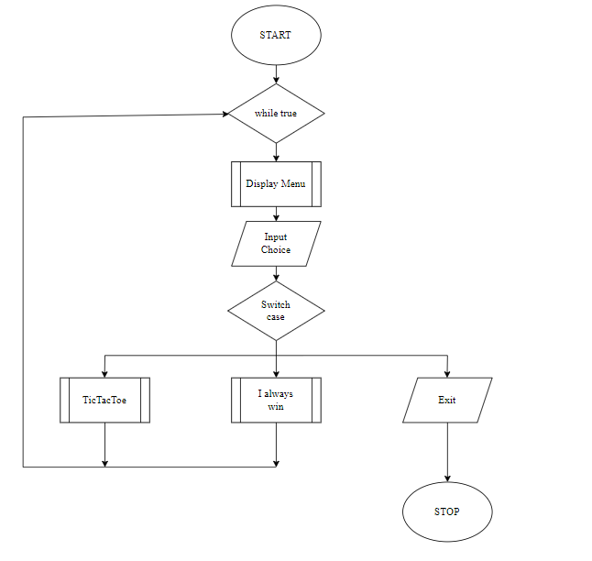

CHAPTER 4:

Major modules with description of their functionalities along with logic.

Creating the board
Arrays — Arrays, hold a special place in shell, not having much more better alternatives to define and use lists. So, I have used arrays, to hold, almost all the lists. The initial board design was pictured like below.

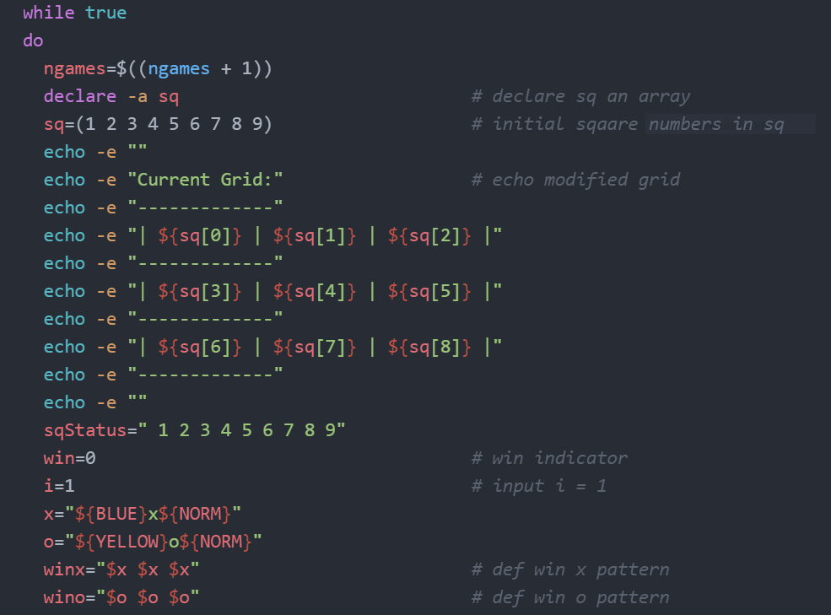

Registering the players

Since, this is a 2 player game and it is not always a fun to play with computer. The player registration was written to take care of having at most 2 player each time and ensure, the script does not control which player would start first, but pick at random.

The available spots, in the single dimension metrics, are updated each time a player choose its move, simply, by checking the value of each indices in the array against it’s default value.

Rotating The Turn

Rotate the turn in 3 simple steps:
- Check, if there are enough free spots in the metrics.
- Allow player to choose it’s spot.
- Set next player to take their turn.

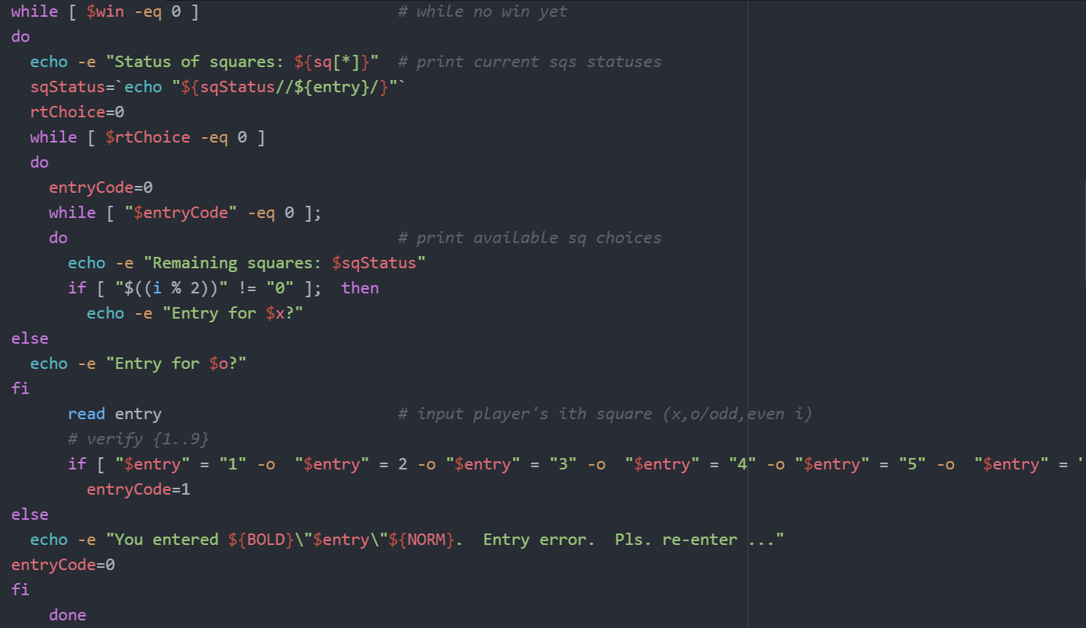
Avoid the cheats
A considerable challenge here is:
- To avoid, the re-selection of the same spot chosen by another player or the same player
- To avoid, player to choose, characters other than allowed o or x.
- To avoid, cheating in the game.
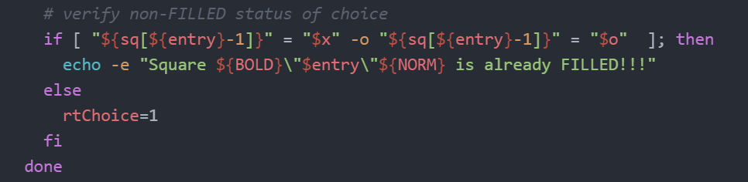

The Winning Combinations
In Tic-Tac-Toe, player first capturing all consecutive spots in a single row or column win. So, all such combinations becomes the winning bet.

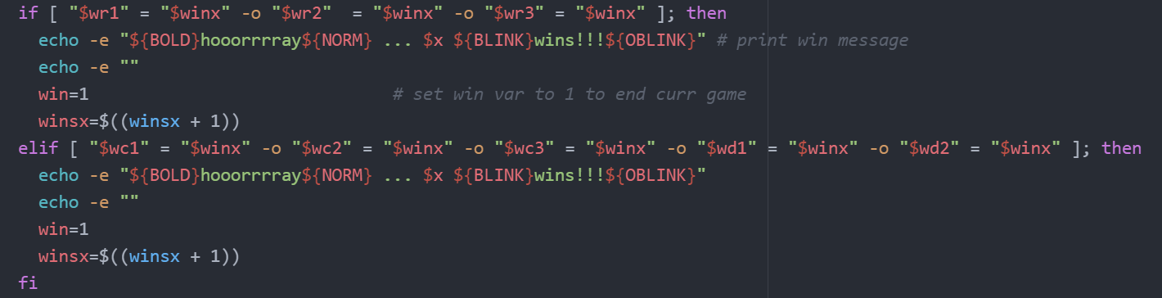

The Score Board
The score board, is designed, keeping in mind, the games ability, to restart again from where it ended and to give players, a better feel of game.

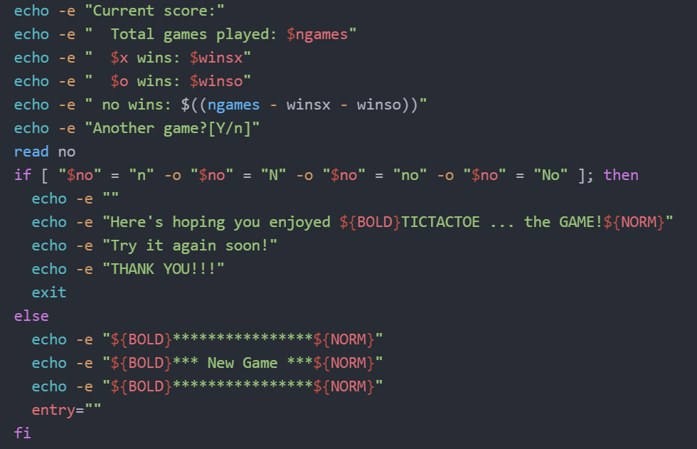

CHAPTER 5: Implementation using shell script

#! /bin/sh
while(true)
do
echo ""
echo "Which game do you whant to play?"
echo "select from bellow"
echo "1. TicTacToe "
echo "2. I always win"
echo "3. Exit"
echo ""
read x
case "$x" in
#Using absolute path
#1) sh /c/Users/Chiranth/desktop/mini_unix/t3C-Copy.sh ;;
#2) sh /c/Users/Chiranth/desktop/mini_unix/i-always-win.sh ;;
#Using relative path
1) ./t3C-Copy.sh ;;
2) ./i-always-win.sh ;;
3) break ;;
esac
done

TIC TAC TOE SCRIPT

#!/bin/bash
#
# Title: TICTACTOE ... the GAME! (For two players, x and o.)
# Filename: t3C-Copy
#
YELLOW='\e[1;33m'
BLUE='\e[1;34m'
BOLD='\e[1;39m'
BLINK='\e[5m'
OBLINK='\e[25m'
NORM='\e[0m'
echo -e ""
echo -e "${BOLD}TICTACTOE ... the GAME!${NORM}"
echo -e "For 2 players: ${BLUE}x${NORM} and ${YELLOW}o${NORM}. First ${BLUE}x${NORM}, then ${YELLOW}o${NORM}."
winsx=0
winso=0
ngames=0
while true
do
ngames=$((ngames + 1))
declare -a sq # declare sq an array
sq=(1 2 3 4 5 6 7 8 9) # initial sqaare numbers in sq
echo -e ""
echo -e "Current Grid:" # echo modified grid
echo -e "-------------"
echo -e "| ${sq[0]} | ${sq[1]} | ${sq[2]} |"
echo -e "-------------"
echo -e "| ${sq[3]} | ${sq[4]} | ${sq[5]} |"
echo -e "-------------"
echo -e "| ${sq[6]} | ${sq[7]} | ${sq[8]} |"
echo -e "-------------"
echo -e ""
sqStatus=" 1 2 3 4 5 6 7 8 9"
win=0 # win indicator
i=1 # input i = 1
x="${BLUE}x${NORM}"
o="${YELLOW}o${NORM}"
winx="$x $x $x" # def win x pattern
wino="$o $o $o" # def win o pattern
while [ $win -eq 0 ] # while no win yet
do
echo -e "Status of squares: ${sq[*]}" # print current sqs statuses
sqStatus=`echo "${sqStatus//${entry}/}"`
rtChoice=0
while [ $rtChoice -eq 0 ]
do
entryCode=0
while [ "$entryCode" -eq 0 ];
do # print available sq choices
echo -e "Remaining squares: $sqStatus"
if [ "$((i % 2))" != "0" ]; then
echo -e "Entry for $x?"
else
echo -e "Entry for $o?"
fi
read entry # input player's ith square (x,o/odd,even i)
# verify {1..9}
if [ "$entry" = "1" -o "$entry" = 2 -o "$entry" = "3" -o "$entry" = "4" -o "$entry" = "5" -o "$entry" = "6" -o "$entry" = "7" -o "$entry" = "8" -o "$entry" = "9" ]; then
entryCode=1
else
echo -e "You entered ${BOLD}\"$entry\"${NORM}. Entry error. Pls. re-enter ..."
entryCode=0
fi
done
# verify non-FILLED status of choice
if [ "${sq[${entry}-1]}" = "$x" -o "${sq[${entry}-1]}" = "$o" ]; then
echo -e "Square ${BOLD}\"$entry\"${NORM} is already FILLED!!!"
else
rtChoice=1
fi
done
if [ "$((i % 2))" != "0" ]; then # player x input; steps 1,3,5,7,9
sq[${entry}-1]="$x" # asign "x" to choice entry
echo -e ""
echo -e "Current Grid:" # echo modified grid
echo -e "-------------"
echo -e "| ${sq[0]} | ${sq[1]} | ${sq[2]} |"
echo -e "-------------"
echo -e "| ${sq[3]} | ${sq[4]} | ${sq[5]} |"
echo -e "-------------"
echo -e "| ${sq[6]} | ${sq[7]} | ${sq[8]} |"
echo -e "-------------"
echo -e ""
wr1="${sq[0]} ${sq[1]} ${sq[2]}" # determine 8 relevant patterns
wr2="${sq[3]} ${sq[4]} ${sq[5]}"
wr3="${sq[6]} ${sq[7]} ${sq[8]}"
wc1="${sq[0]} ${sq[3]} ${sq[6]}"
wc2="${sq[1]} ${sq[4]} ${sq[7]}"
wc3="${sq[2]} ${sq[5]} ${sq[8]}"
wd1="${sq[0]} ${sq[4]} ${sq[8]}"
wd2="${sq[2]} ${sq[4]} ${sq[6]}" # compare 8 relevant patterns to winx patterns
if [ "$wr1" = "$winx" -o "$wr2" = "$winx" -o "$wr3" = "$winx" ]; then
echo -e "${BOLD}hooorrrray${NORM} ... $x ${BLINK}wins!!!${OBLINK}" # print win message
echo -e ""
win=1 # set win var to 1 to end curr game
winsx=$((winsx + 1))
elif [ "$wc1" = "$winx" -o "$wc2" = "$winx" -o "$wc3" = "$winx" -o "$wd1" = "$winx" -o "$wd2" = "$winx" ]; then
echo -e "${BOLD}hooorrrray${NORM} ... $x ${BLINK}wins!!!${OBLINK}"
echo -e ""
win=1
winsx=$((winsx + 1))
fi
i=$((i + 1)) # increment step i
if [ $i -ge 10 -a $win = 0 ]; then # game ends in 9 or less steps
echo -e "${BOLD}${BLINK}No winner! ... ${OBLINK}${NORM}"
echo -e ""
win=1 # let win=1 to end curr game
fi
else
sq[${entry}-1]="$o" # player o input; steps 2,4,6,8
echo -e ""
echo -e "Current Grid:" # echo modified grid
echo -e "-------------"
echo -e "| ${sq[0]} | ${sq[1]} | ${sq[2]} |"
echo -e "-------------"
echo -e "| ${sq[3]} | ${sq[4]} | ${sq[5]} |"
echo -e "-------------"
echo -e "| ${sq[6]} | ${sq[7]} | ${sq[8]} |"
echo -e "-------------"
echo -e ""
wr1="${sq[0]} ${sq[1]} ${sq[2]}"
wr2="${sq[3]} ${sq[4]} ${sq[5]}"
wr3="${sq[6]} ${sq[7]} ${sq[8]}"
wc1="${sq[0]} ${sq[3]} ${sq[6]}"
wc2="${sq[1]} ${sq[4]} ${sq[7]}"
wc3="${sq[2]} ${sq[5]} ${sq[8]}"
wd1="${sq[0]} ${sq[4]} ${sq[8]}"
wd2="${sq[2]} ${sq[4]} ${sq[6]}"
if [ "$wr1" = "$wino" -o "$wr2" = "$wino" -o "$wr3" = "$wino" ]; then
echo -e "${BOLD}hooorrrray${NORM} ... $o ${BLINK}wins!!!${OBLINK}"
echo -e ""
win=1
winso=$((winso + 1))
elif [ "$wc1" = "$wino" -o "$wc2" = "$wino" -o "$wc3" = "$wino" -o "$wd1" = "$wino" -o "$wd2" = "$wino" ]; then
echo -e "${BOLD}hooorrrray${NORM} ... $o ${BLINK}wins!!!${OBLINK}"
echo -e ""
win=1
winso=$((winso + 1))
fi
i=$((i + 1)) # increment step i
fi
done
echo -e "Current score:"
echo -e " Total games played: $ngames"
echo -e " $x wins: $winsx"
echo -e " $o wins: $winso"
echo -e " no wins: $((ngames - winsx - winso))"
echo -e "Another game?[Y/n]"
read no
if [ "$no" = "n" -o "$no" = "N" -o "$no" = "no" -o "$no" = "No" ]; then
echo -e ""
echo -e "Here's hoping you enjoyed ${BOLD}TICTACTOE ... the GAME!${NORM}"
echo -e "Try it again soon!"
echo -e "THANK YOU!!!"
exit
else
echo -e "${BOLD}****************${NORM}"
echo -e "${BOLD}*** New Game ***${NORM}"
echo -e "${BOLD}****************${NORM}"
entry=""
fi
done

I ALWAYS WIN SCRIPT

#!/bin/bash
# game where computer always wins

total=20
remaining=$total
max_selection=5
min_selection=1
p1=''
p2=computer
violations=0
YELLOW="\e[33m"
GREEN="\e[32m"
NC="\e[0m"
declare -a players=(p1 p2)
declare -a users

check_player()
{
for user in ${players[@]}; do
if [ x${!user} = x ]; then
echo -e "error: ${user} has no name !!"
exit 1
else
users=(${users[@]} ${!user})
echo -e "info: ${user} -> ${!user} has joined the game."
fi
done

}

printf "\e[2J\e[H"

echo -e "$YELLOW"
echo -e "$NC"

read -p "your name: " p1

while true; do
read -p "info: start the game? y/n, ans: " yn
case $yn in
[Yy] ) echo -e "info: starting the game..\n"; break;;
[Nn] ) echo -e "info: one of the player has opted to quit!!"; exit 1;;
* ) echo -e "error: wrong choice, try again!!\n";;
esac
done

check_player

i=1;

while [ $remaining -gt 0 ]; do

echo -e "\n==============================="
echo -e "ROUND $i: $remaining/$total available"
echo -e "===============================\n"

for user in ${users[@]}; do
if [ "${user}" != "computer" ]; then
read -p "[${user}] select a number[1-5]: " choice
echo
else
choice=$((RANDOM%5+1))

case $remaining in
12 ) choice=5;;
11 ) choice=4;;
10 ) choice=3;;
9 ) choice=2;;
8 ) choice=1;;
[2-6] ) choice=$(expr $remaining - 1)
esac

sleep 1s
fi

if [[ $choice -le 5 ]] && [[ $choice -ne 0 ]]; then
echo -e "$YELLOW[${user}]$NC selected $choice"
dif=$choice
((remaining-=dif))
else
echo -e "$YELLOW[${user}]$NC selected $choice, has cheated by violating the game rules.\n"
echo -e "\n\n******\$\$\$\$\$$GREEN[${users[@]/${user}/}]$NC wins the game\$\$\$\$\$******\n\n"
exit 1
fi

if [ $remaining -le 0 ]; then
echo -e "\n\n******\$\$\$\$\$$GREEN[${users[@]/${user}/} ]$NC wins the game\$\$\$\$\$******\n\n"
exit 0
fi
done

((i+=1))
Done

CHAPTER 6: SCREEN SHOTS

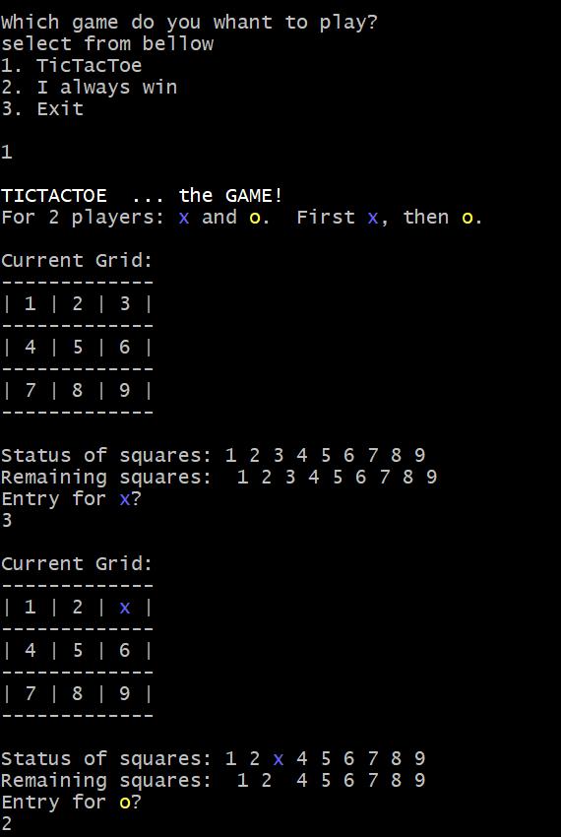
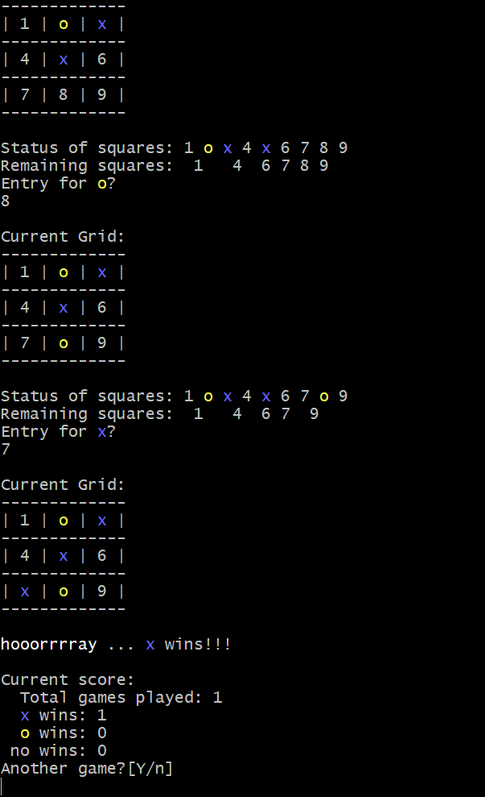
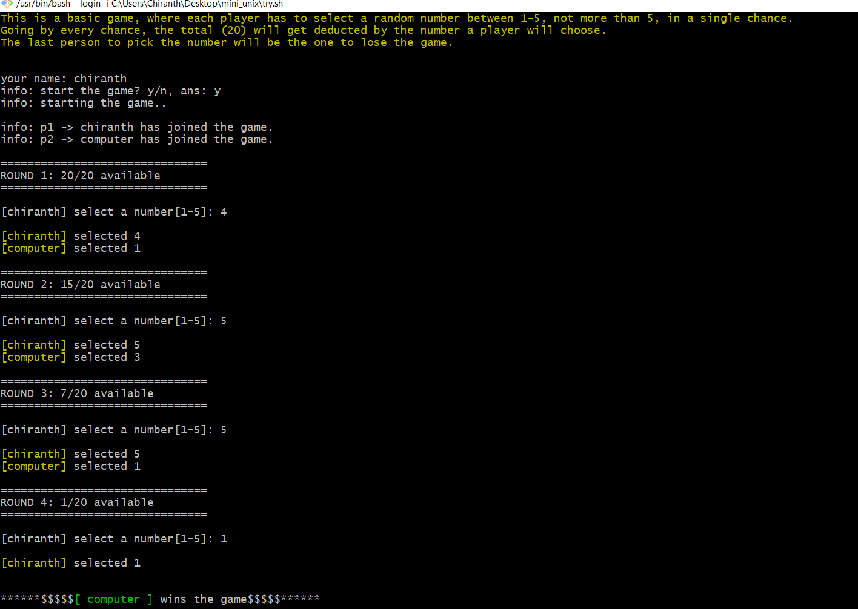

CHAPTER 7: APPLICATION

The command and syntax are exactly the same as those directly entered in command line, so programmer do not need to switch to entirely different syntax
- Writing shell scripts are much quicker
- Quick start
- Interactive debugging etc.

CHAPTER 8: CONCLUSION

Games are most familiar among all the age groups.
Intelligence can be a property of any purpose-driven decision maker. This basic idea was to use shell programming and implement the game. Tic Tac Toe and i-always- win games was presented and tested that works in an efficient way. Overall the system works without any bugs.

